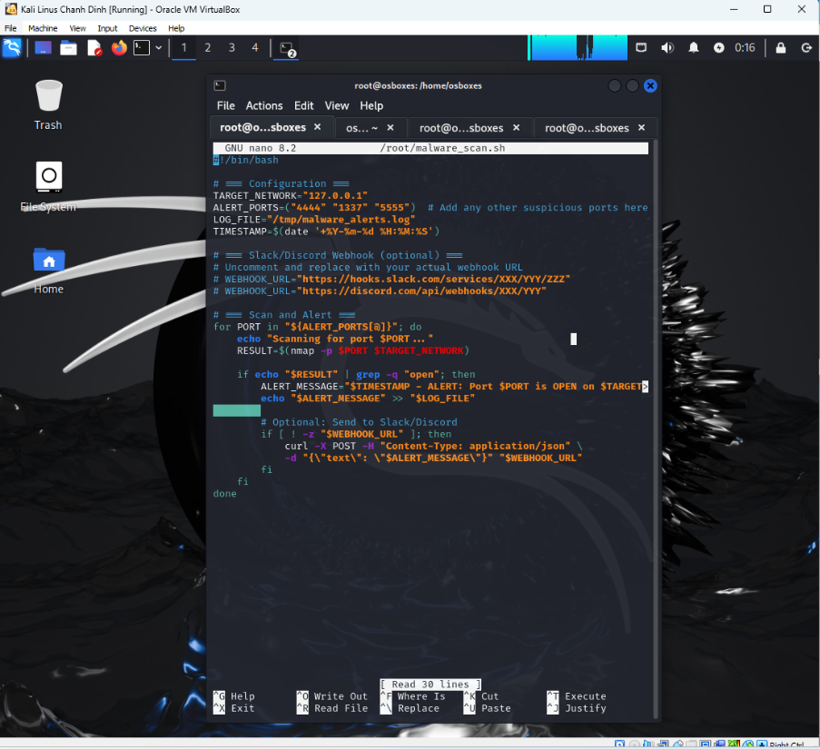

~/malware_scan.sh

Cat /tmp/malware_alerts.log